|  |  |
| --- | --- |
| **DOKUMENTASI EKSTERNAL**  External Documentation |  |
| **[PROYEK]**  **[*Project*]** |
| **MATAKULIAH <COMP6176> – Human and Computer Interaction**  ***Subject*** |
| SEMESTER [GENAP] 2020/2021 ***[Even] Semester Year 2020/2021*** |

**Letflix**

Letflix is a well-known cinema company, founded in October 1977 by Joan Phoenix in Indonesia. Letflix has opened many branches of international cinema in the world. By prioritizing high-quality dramas and advances in digital technology, Letflix has experienced very rapid growth because it is liked by many customers. Letflix decided to open a digital streaming service in 2011. In 2012, Letflix received the award as the best digital drama streaming service company and streaming service with the most subscribers in the world. This company has a good culture such as being open to complaints and good communication. Relations with investors are also good, where letflix continues to monitor the stock market, customer complain and do so openly to increase the company's investors. We also hold frequent meetings with investors to listen to their opinions and advance the company. Letflix also provide carrers. Joining our team, working with great role such as software engineer, ui/ux designer, data analyst, and many more. We're working with kindess and compassion.

## Dokumentasi

*Report / Documentation*

* **REPORT / PRINT SCREEN & DESCRIPTION**
  + **DETAIL 1**

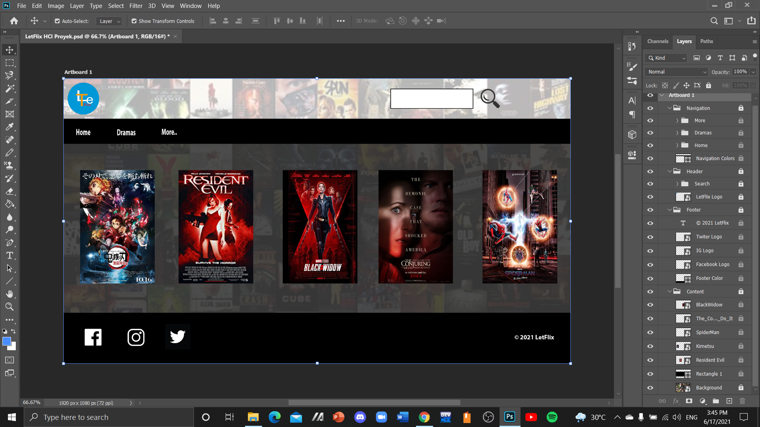

* + **DETAIL 2**

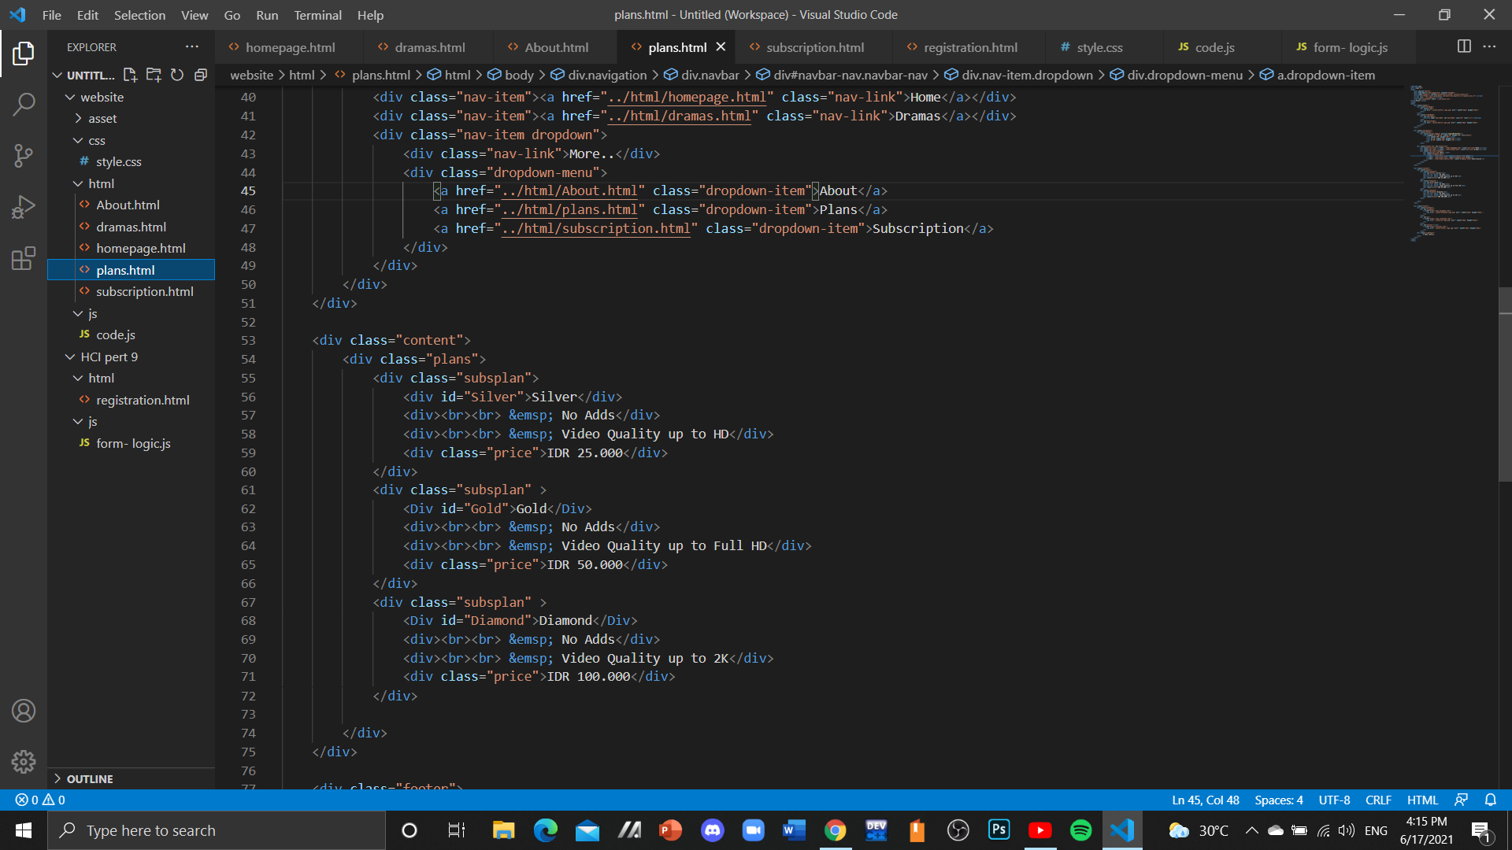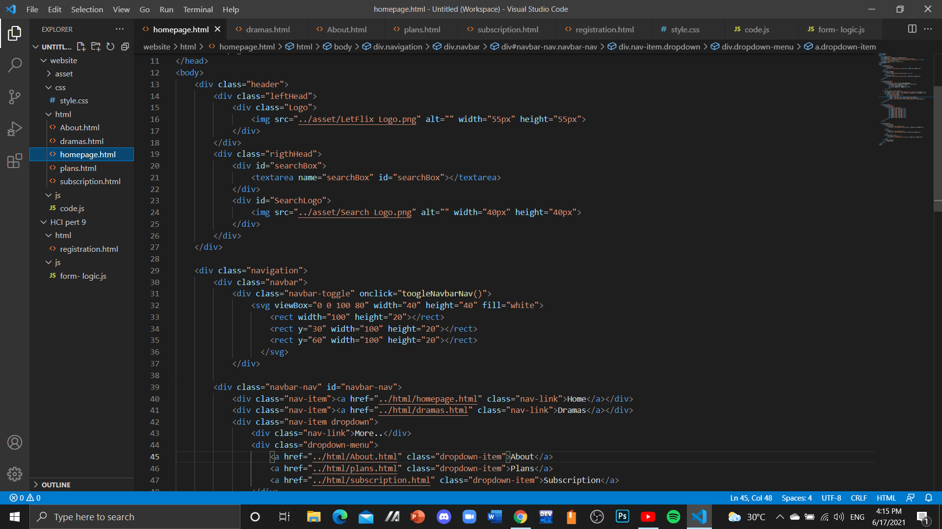

References :

* Google
* Video Class AsLab

Link :

1. Logo search

[*https://www.freepnglogos.com/uploads/search-png/search-cartoon-icon-transparent-png-stickpng-19.png*](https://www.freepnglogos.com/uploads/search-png/search-cartoon-icon-transparent-png-stickpng-19.png)*"*

1. Background

[*https://i.pinimg.com/564x/e9/dc/4f/e9dc4fe5adae6e27e39dcd9dbdf072f6.jpg*](https://i.pinimg.com/564x/e9/dc/4f/e9dc4fe5adae6e27e39dcd9dbdf072f6.jpg)

1. Film Kimetsu

[*https://cdn.myanimelist.net/images/anime/1704/106947.jpg*](https://cdn.myanimelist.net/images/anime/1704/106947.jpg)

4. Film Residen Evil

[*https://m.media-amazon.com/images/M/MV5BZmI1ZGRhNDYtOGVjZC00MmUyLThlNTktMTQyZGE3MzE1ZTdlXkEyXkFqcGdeQXVyNDE5MTU2MDE@._V1_UY268_CR1,0,182,268_AL_.jpg*](https://m.media-amazon.com/images/M/MV5BZmI1ZGRhNDYtOGVjZC00MmUyLThlNTktMTQyZGE3MzE1ZTdlXkEyXkFqcGdeQXVyNDE5MTU2MDE@._V1_UY268_CR1,0,182,268_AL_.jpg)

5. Film Conjuring

[*https://upload.wikimedia.org/wikipedia/en/e/e8/The_Conjuring_-_The_Devil_Made_Me_Do_It.png*](https://upload.wikimedia.org/wikipedia/en/e/e8/The_Conjuring_-_The_Devil_Made_Me_Do_It.png)

6. Film Spiderman

[*https://i.pinimg.com/564x/7e/45/0c/7e450cc161c6595e3852daa0233f09d5.jpg*](https://i.pinimg.com/564x/7e/45/0c/7e450cc161c6595e3852daa0233f09d5.jpg)

7. Film Black Widow

[*https://cdn0-production-images-kly.akamaized.net/zC4Kw13SCjlA_egoL7jwdkZ6awo=/640x853/smart/filters:quality(75):strip_icc():format(jpeg)/kly-media-production/medias/3079617/original/085141800_1584514176-Black_Widow.jpg*](https://cdn0-production-images-kly.akamaized.net/zC4Kw13SCjlA_egoL7jwdkZ6awo=/640x853/smart/filters:quality(75):strip_icc():format(jpeg)/kly-media-production/medias/3079617/original/085141800_1584514176-Black_Widow.jpg)

8. Logo Facebook

[*https://www.pikpng.com/pngl/b/102-1028473_free-png-download-facebook-logo-white-png-images.png*](https://www.pikpng.com/pngl/b/102-1028473_free-png-download-facebook-logo-white-png-images.png)

9. Logo Instagram

[*https://www.pngfind.com/pngs/b/2-22629_instagram-png.png*](https://www.pngfind.com/pngs/b/2-22629_instagram-png.png)

10. Logo Twitter

[*https://icon-library.com/images/twitter-icon-white-transparent/twitter-icon-white-transparent-24.jpg*](https://icon-library.com/images/twitter-icon-white-transparent/twitter-icon-white-transparent-24.jpg)

11. Logo Arrow

[*https://www.pngkey.com/png/full/12-120716_free-black-right-arrow-icon-png-vector-right.png*](https://www.pngkey.com/png/full/12-120716_free-black-right-arrow-icon-png-vector-right.png)

12. Drama Lokal Dari Jendela SMP

[*https://cdn.sctv.co.id/tag/2019/01/08/28004/orang-ketiga-rev4.jpg*](https://cdn.sctv.co.id/tag/2019/01/08/28004/orang-ketiga-rev4.jpg)

13. Drama Lokal Samudra Cinta

[*https://cdn.sctv.co.id/tag/2019/01/08/28001/cinta-misteri-rev3.jpg*](https://cdn.sctv.co.id/tag/2019/01/08/28001/cinta-misteri-rev3.jpg)

14. Drama Lokal Love Story the Series

[*https://cdn.sctv.co.id/tag/2019/01/08/28002/anak-langit-rev4.jpg*](https://cdn.sctv.co.id/tag/2019/01/08/28002/anak-langit-rev4.jpg)

15. Drama Lokal Buku Harian Seorang Istri

[*https://cdn.sctv.co.id/tag/2019/01/08/28003/cinta-suci-rev4.jpg*](https://cdn.sctv.co.id/tag/2019/01/08/28003/cinta-suci-rev4.jpg)

Disiapkan oleh :

* **2440069514 – Ignatius Alexander Hery**
* **2440022252 – Owen Albert Salomo**
* **2440018116 – Jovan Wesly**